**1.Fabric Sales Per Year Per Month**

SELECT T.fabric_id, f.fabric_name, T.total_price, T.month, T.year

FROM

(

select pfm.fabric_id,

DATE_PART(month, transaction_date) as month,

DATE_PART(year, transaction_date) as year,

SUM(t.price) as total_price

from transactions t

join articles a on t.article_id = a.article_id

join product_fabric_map pfm on pfm.product_code = a.product_code

join fabric f on f.fabric_id = pfm.fabric_id

group by pfm.fabric_id, DATE_PART(month, transaction_date), DATE_PART(year, transaction_date)

) as T

JOIN fabric f on f.fabric_id = T.fabric_id

order by T.year, T.month ASC;

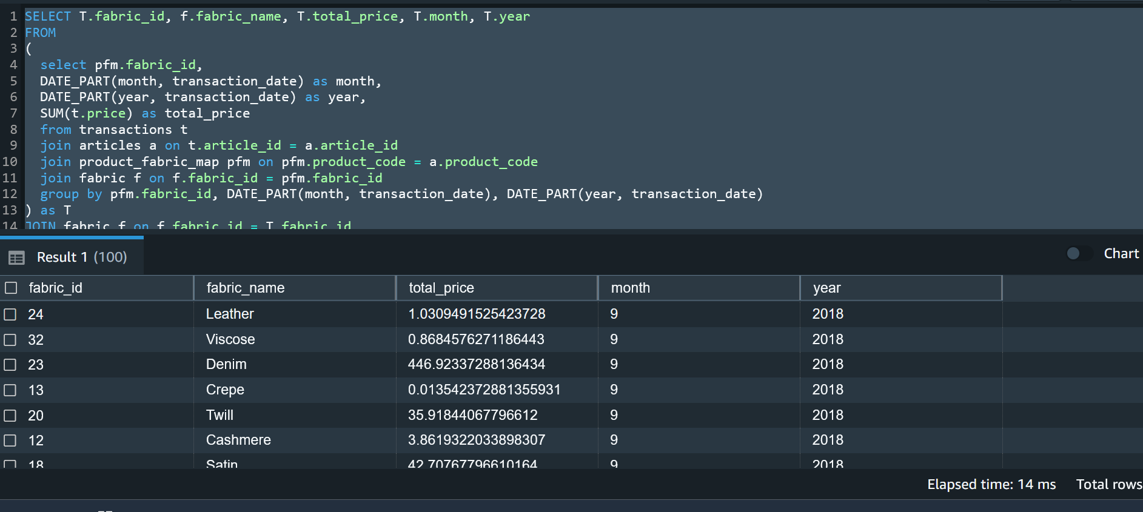

**2.Overall most sold fabric with total sales**

SELECT T.fabric_id, f.fabric_name, T.total_price

FROM

(

select pfm.fabric_id, SUM(t.price) as total_price

from transactions t

join articles a on t.article_id = a.article_id

join product_fabric_map pfm on pfm.product_code = a.product_code

join fabric f on f.fabric_id = pfm.fabric_id

group by pfm.fabric_id

) as T

JOIN fabric f on f.fabric_id = T.fabric_id

order by T.total_price DESC;

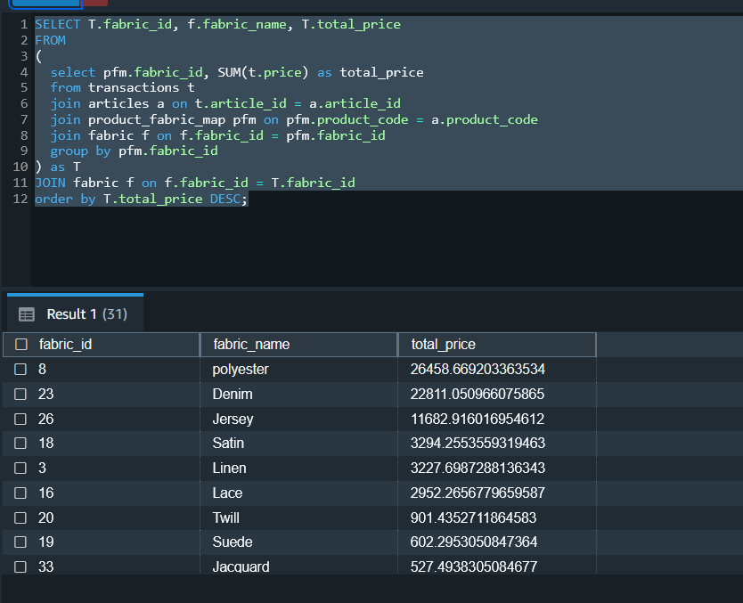

**3.Most sold fabric with total sales Per Year Per Month**

SELECT S.fabric_id, f.fabric_name, S.month, S.year, S.total_price

FROM (

select T.fabric_id, T.month, T.year, T.total_price,

MAX(T.total_price) over (partition by T.month, T.year) as max_sale

from

(

select pfm.fabric_id,

DATE_PART(month, transaction_date) as month,

DATE_PART(year, transaction_date) as year,

SUM(t.price) as total_price

from transactions t

join articles a on t.article_id = a.article_id

join product_fabric_map pfm on pfm.product_code = a.product_code

join fabric f on f.fabric_id = pfm.fabric_id

group by pfm.fabric_id, DATE_PART(month, transaction_date), DATE_PART(year, transaction_date)

) AS T

) AS S

JOIN fabric f on f.fabric_id = S.fabric_id

WHERE S.total_price = S.max_sale

order by S.year, S.month;

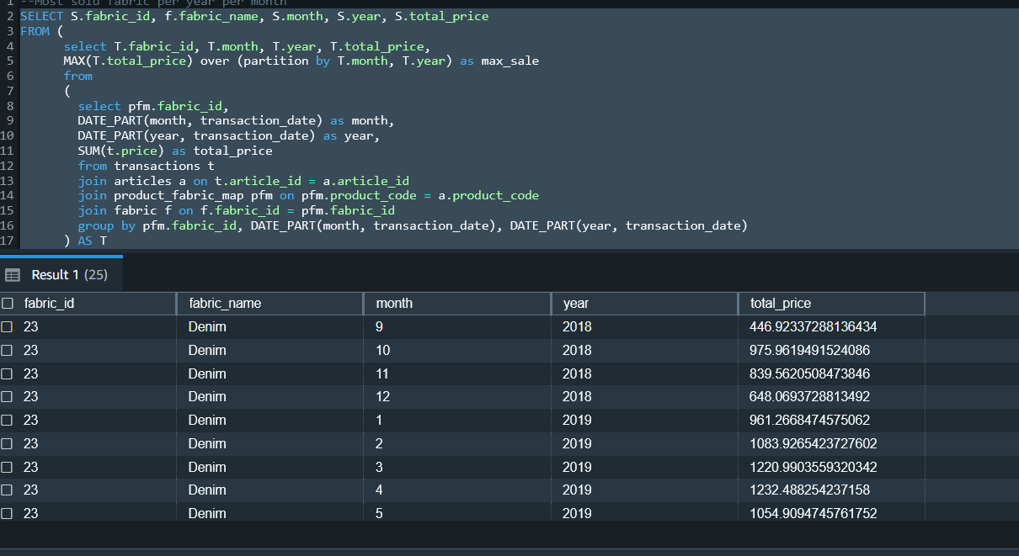

**4. Creation of view**

CREATE ALGORITHM=UNDEFINED DEFINER=`root`@`localhost` SQL SECURITY DEFINER VIEW `getyourbestfit` AS

select distinct `pcm`.`article_id` AS `article_id`,`p`.`product_code` AS `product_code`,

`p`.`product_type_id` AS `product_type_id`,`p`.`prod_name` AS `prod_name`,

`p`.`detail_desc` AS `detail_desc`,`pt`.`type_name`

AS `product_type`,`c`.`bodytype` AS `body_type`,`c`.`skin_condition_level`

AS `skin_condition_level`,`f`.`level` AS `fabric_level`

from ((((((((`product` `p` join `product_type` `pt` on((`pt`.`product_type_id` = `p`.`product_type_id`)))

join `product_style_map` `psm` on((`p`.`product_code` = `psm`.`product_code`)))

join `product_style` `ps` on((`ps`.`product_style_id` = `psm`.`product_style_id`)))

join `product_color_map` `pcm` on((`pcm`.`product_code` = `p`.`product_code`)))

join `body_style_map` `bsm` on((`bsm`.`product_style_id` = `ps`.`product_style_id`)))

join `customer` `c` on((`c`.`body_type_id` = `bsm`.`body_type_id`)))

join `product_fabric_map` `pfm` on((`p`.`product_code` = `pfm`.`product_code`)))

join `fabric` `f` on((`f`.`fabric_id` = `pfm`.`fabric_id`)))

5. Find the rank of product based on the price and transaction date of the product.

SELECT distinct p.prod_name as product, price, t.transaction_date,

RANK() OVER(PARTITION BY p.prod_name ORDER BY price DESC) Rank

from transactions t,product p,product_color_map pcm,

product_type pt,product_group pg

where t.article_id=pcm.article_id and pcm.product_code=p.product_code and

pt.product_group_id=pg.product_group_id and p.product_type_id=pt.product_type_id

order by Rank asc;

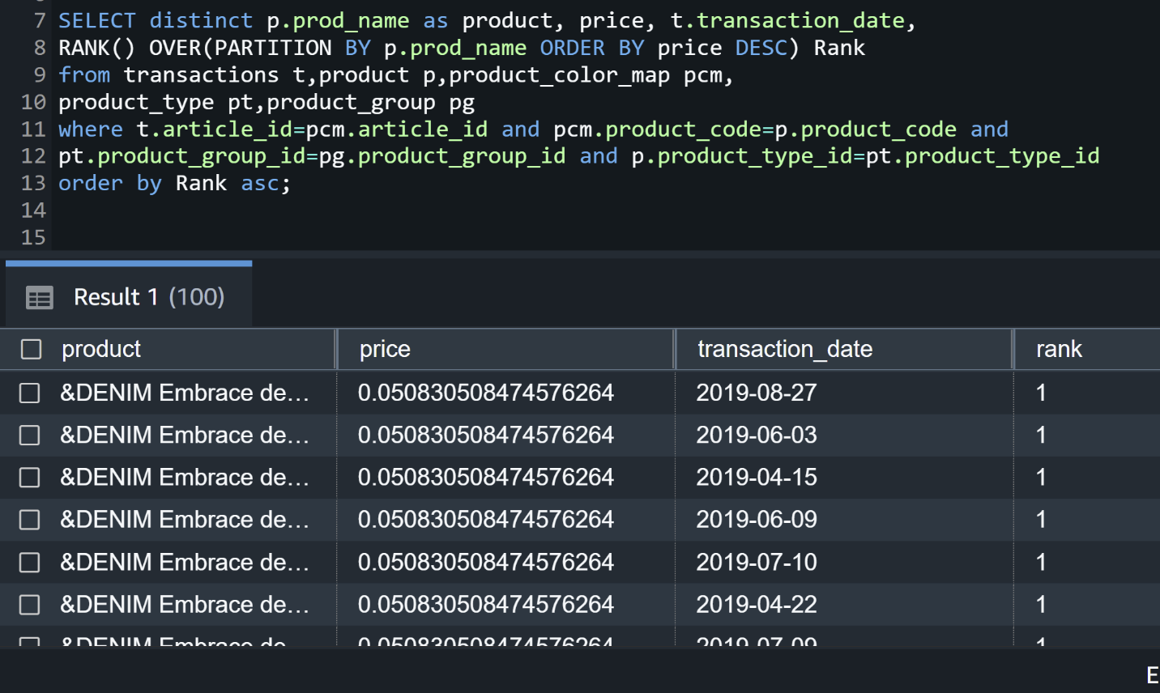

**5.List the name and total number of fabrics with their quality level.**

select fabric_name,level,count(*) over(partition by level) Total_Number from fabric;

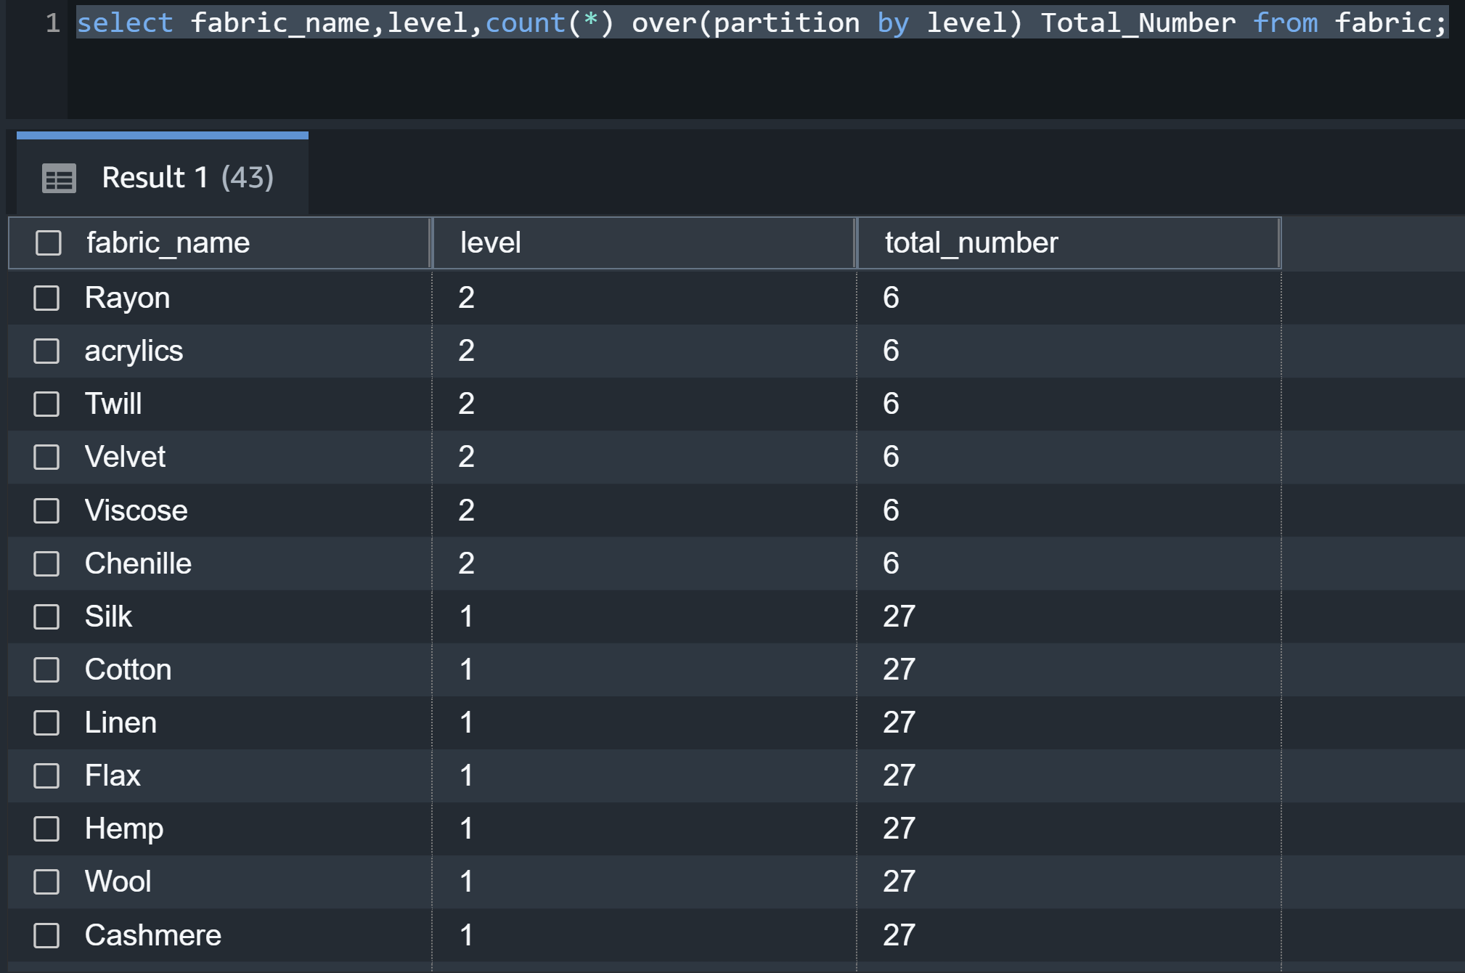

**6. List the product types per group**

select pt.type_name,pg.group_name from product_type pt,product_group pg

where pt.product_group_id=pg.product_group_id

group by pg.group_name,pt.type_name

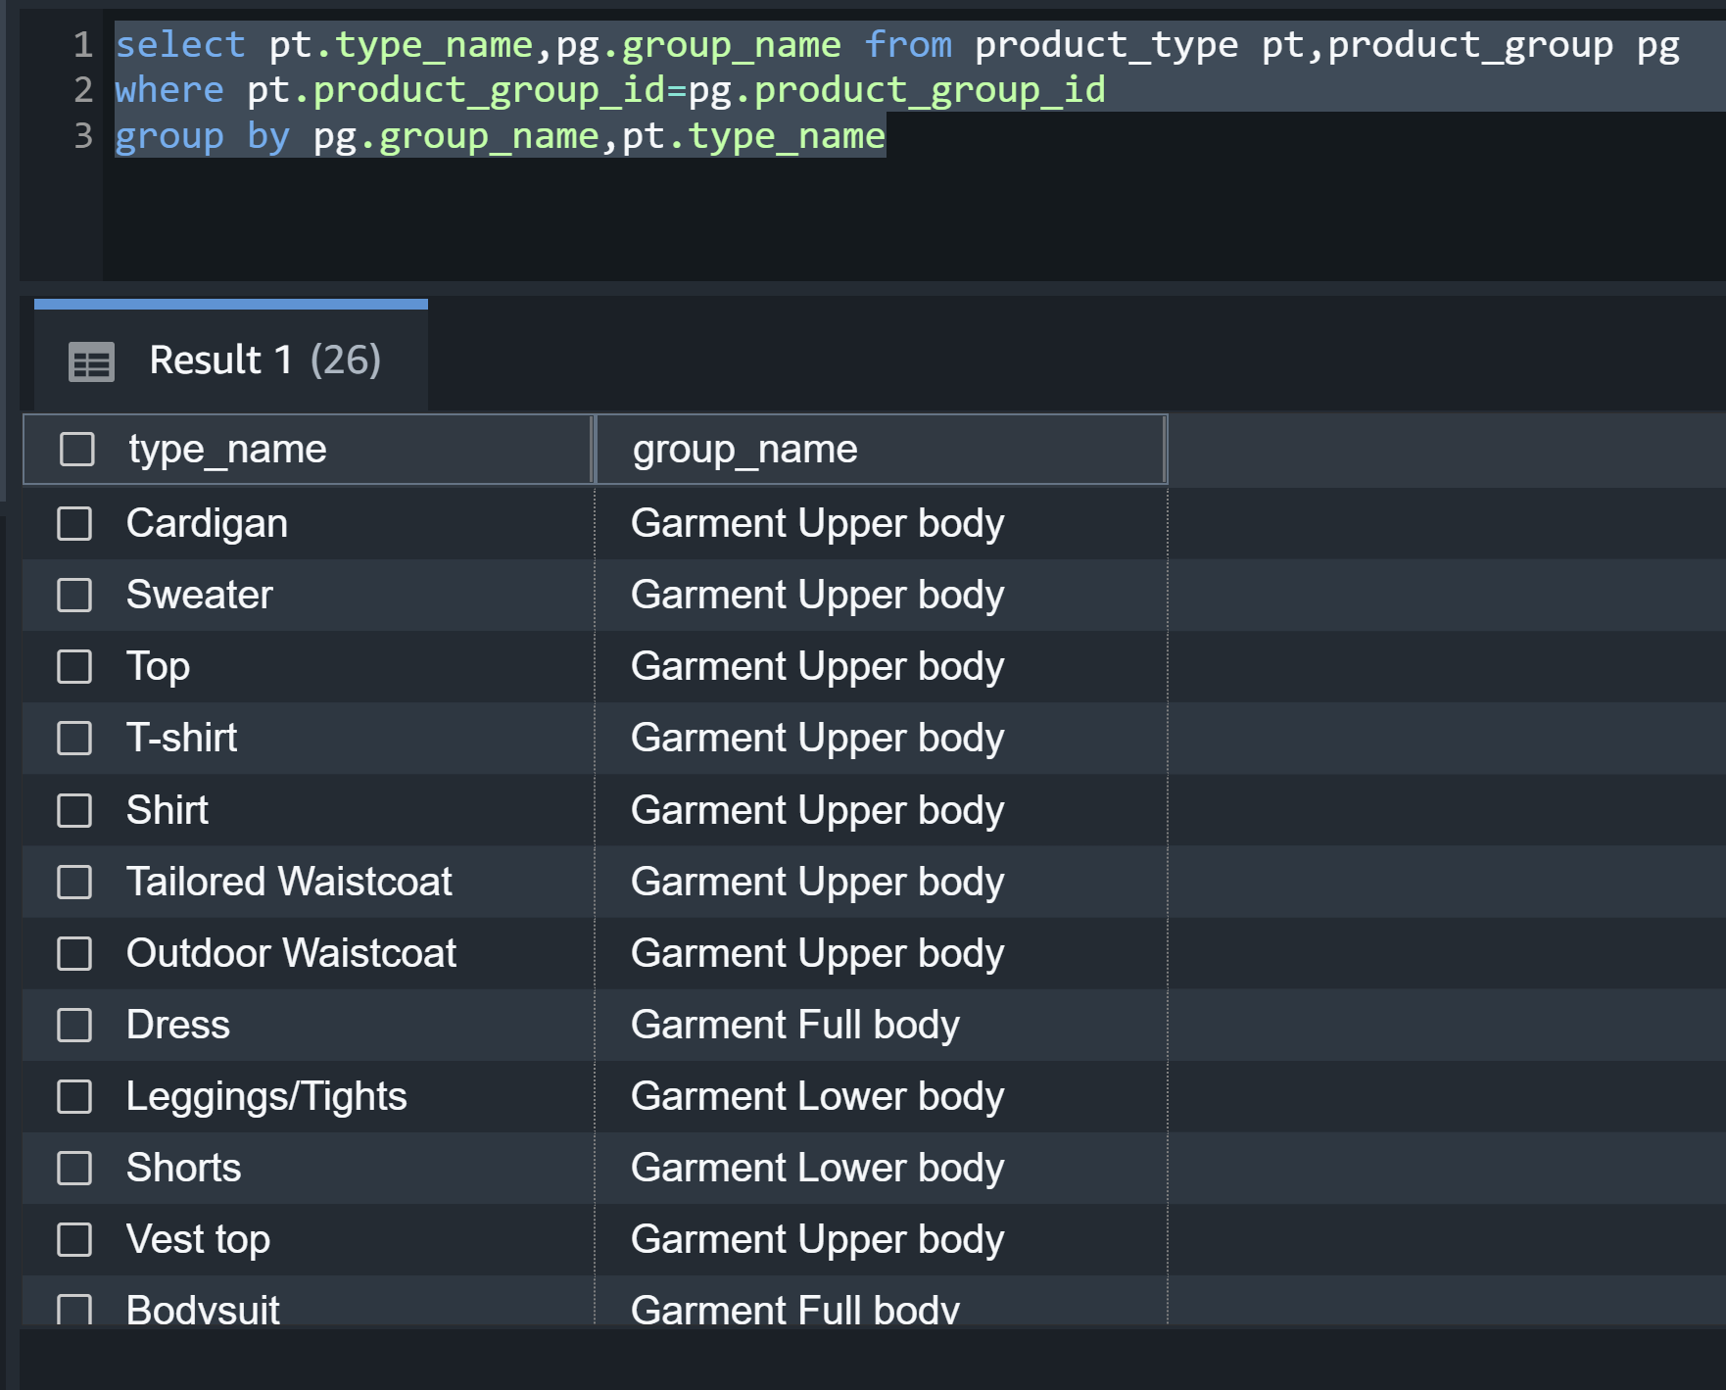

**7.We need to find the total number of products with distinct fabrics with their quality level associated with them.**

select distinct fabric_name, level as Qualitylevel,

count(prod_name) over(partition by f.fabric_name) number_of_products_per_fabric

from product p,fabric f,product_fabric_map fm

where p.product_code=fm.product_code and f.fabric_id=fm.fabric_id

group by fabric_name,level,prod_name

order by number_of_products_per_fabric desc

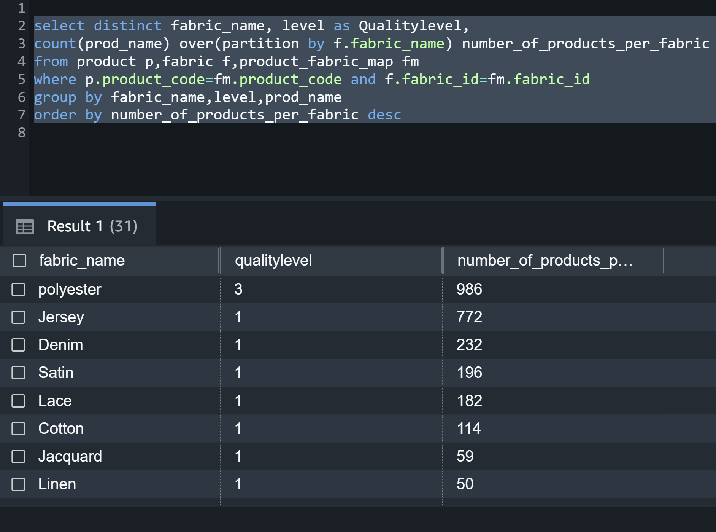

**8. List name and number of product styles per body type.**

select style_name,body_type_name,

count(*) over(partition by body_type_name) number_of_styles_per_bodyType

from product_style ps,body_style_map bsm,body_type b

where ps.product_style_id=bsm.product_style_id

and bsm.body_type_id=b.body_type_id

order by number_of_styles_per_bodyType desc

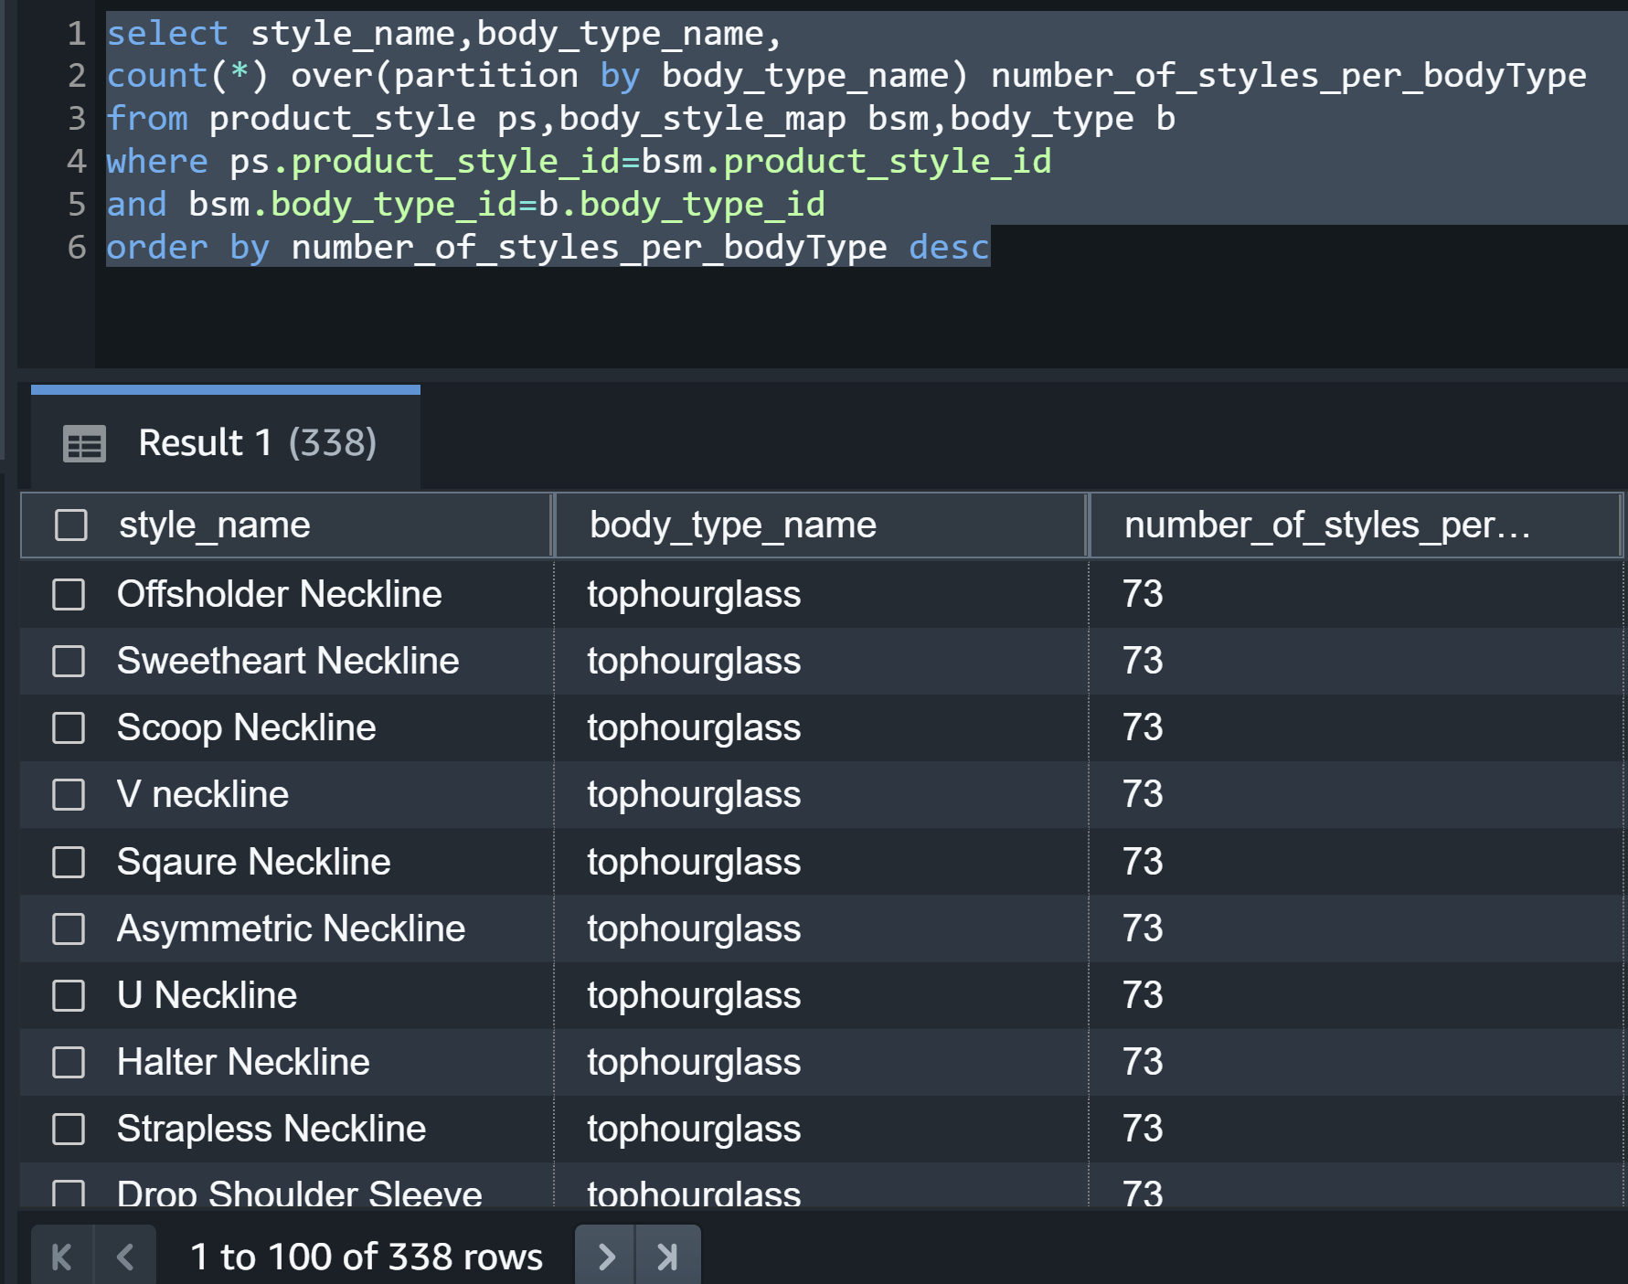

**9.Find total number of customers per bodytype**

select distinct bodytype,count(*) over(partition by body_type_id) totalNoWithBodyType from customer

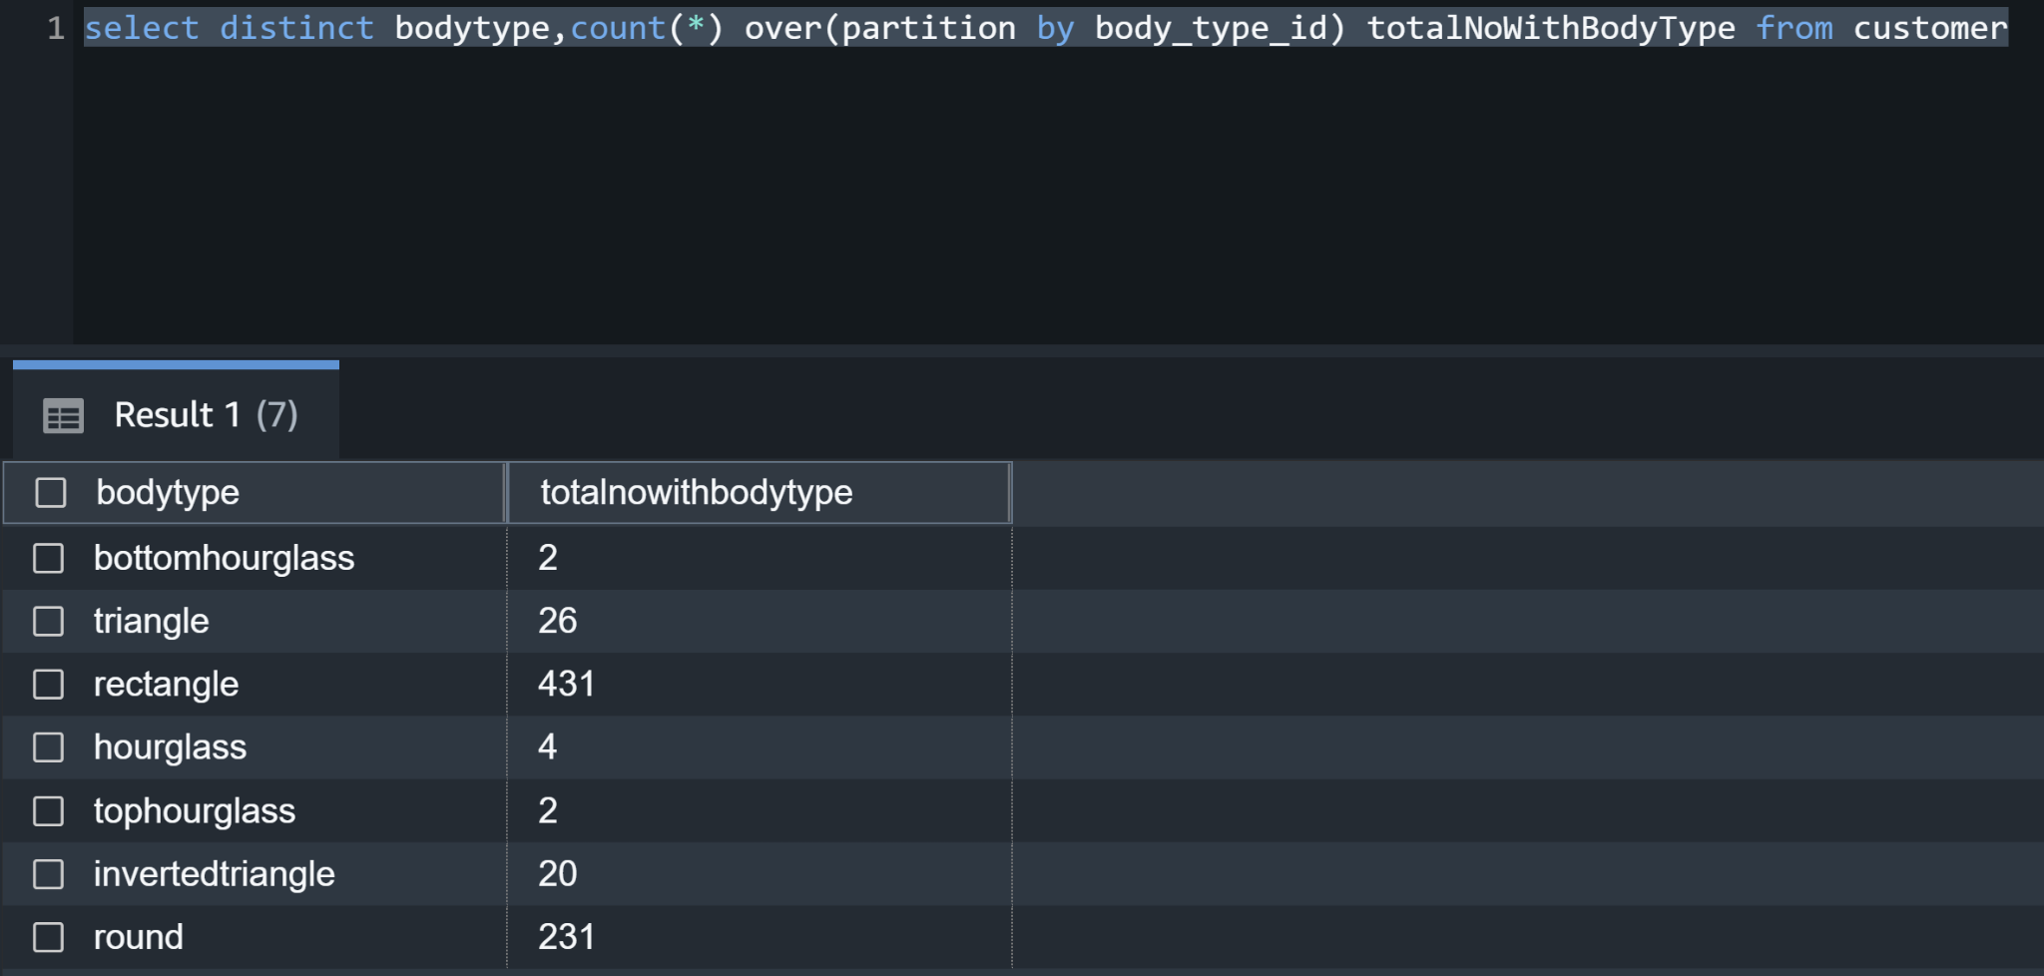

**10. People with different skin conditions**

select distinct skin_condition_level,count(*) over(partition by skin_condition_level) totalNoWithDifferentSkinConditions from customer

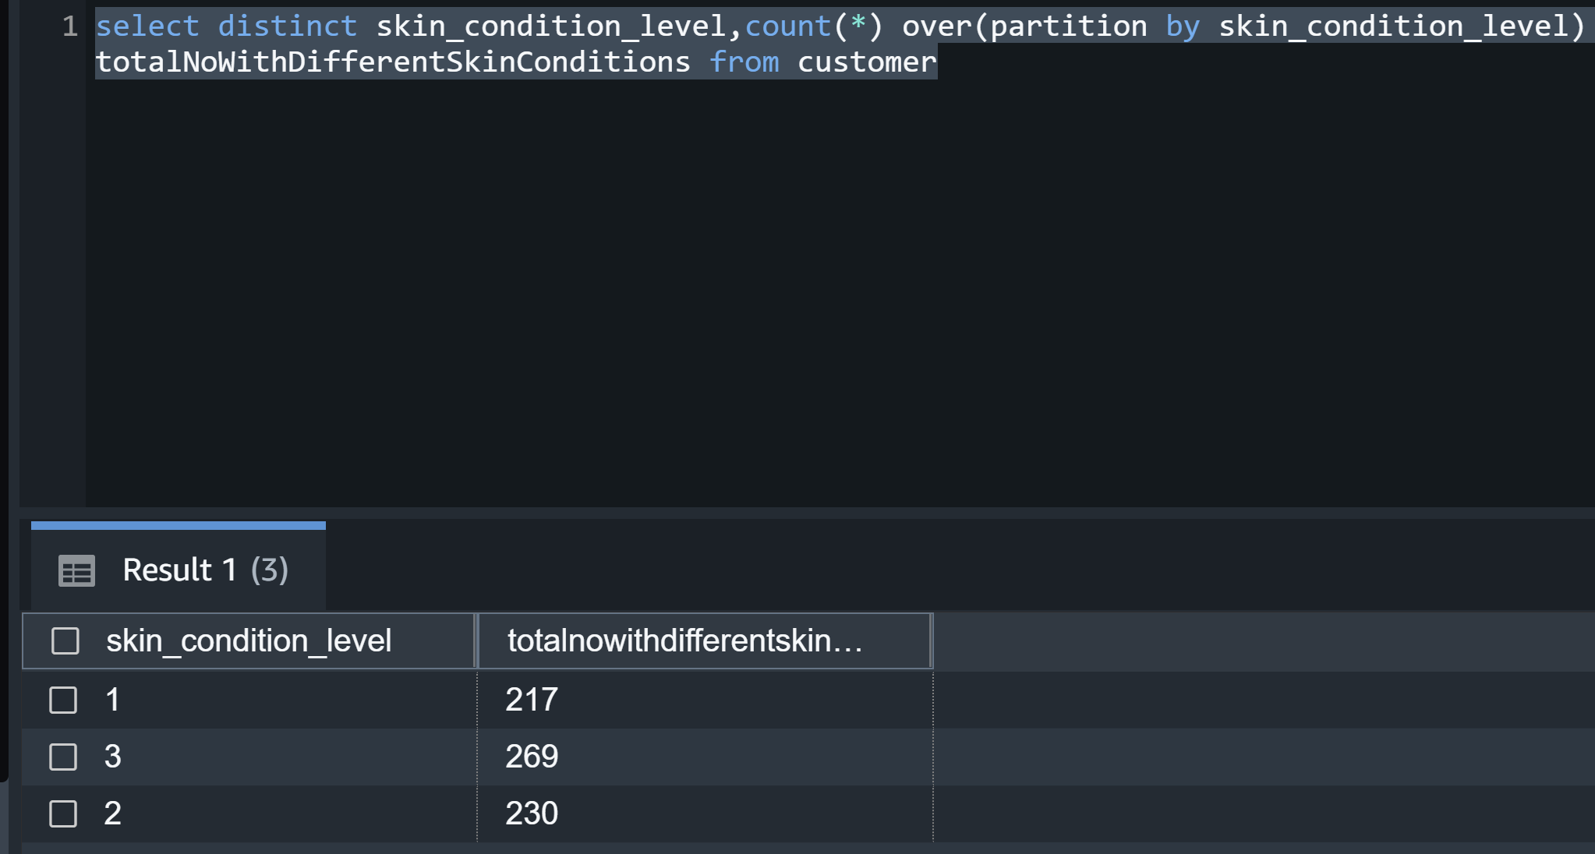

**11.** **Average pricing per product group.**

select distinct pg.group_name,avg(price) over (partition by pt.product_group_id) AvgPrice

from transactions t,product p,product_color_map pcm,

product_type pt,product_group pg

where t.article_id=pcm.article_id and pcm.product_code=p.product_code and

pt.product_group_id=pg.product_group_id and p.product_type_id=pt.product_type_id;

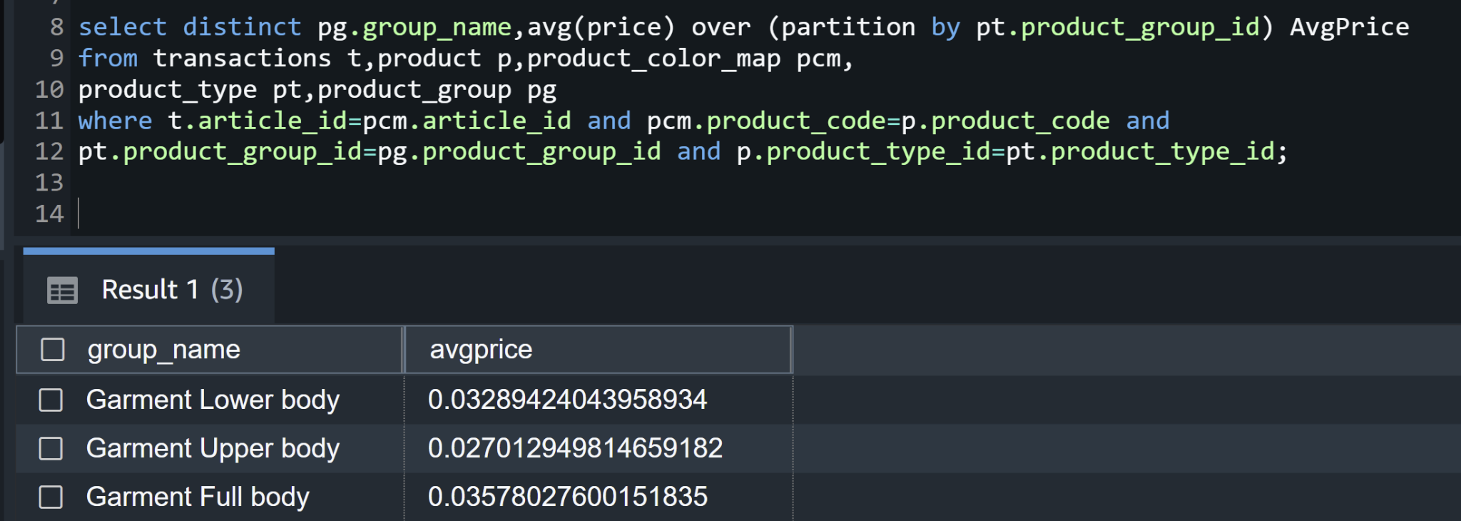

**12.Number of transactions for every quarter of the year**

select extract(YEAR from transaction_date) as year,

extract(QUARTER from transaction_date) as quarter,

count(price) as number_of_transactions

from transactions

group by extract(YEAR from transaction_date),extract(QUARTER from transaction_date)

order by extract(YEAR from transaction_date) asc, extract(QUARTER from transaction_date);

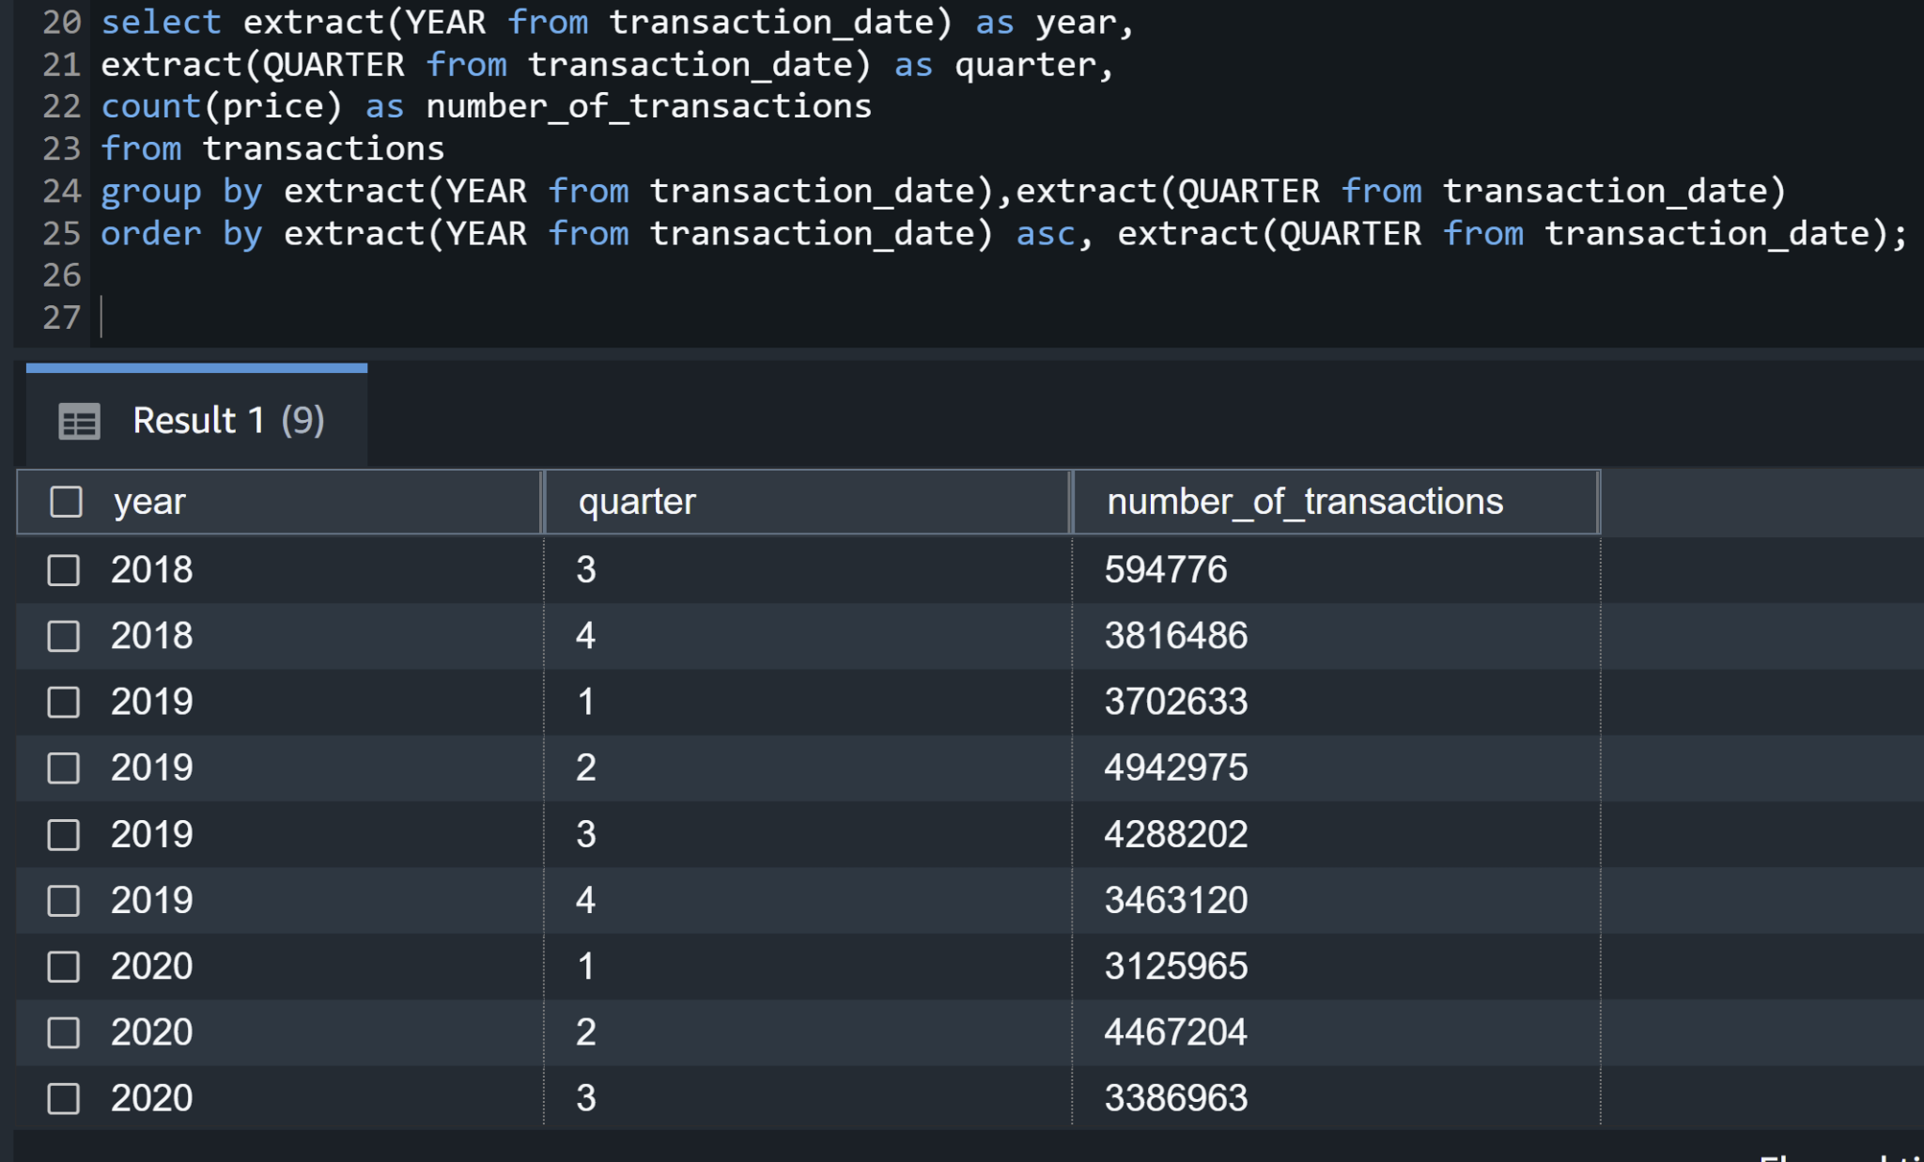

**13.** **List Per day transaction running amount per product type for year 2020.**

select distinct(t.transaction_date) , pt.type_name,

sum(t.price) over (PARTITION BY p.prod_name ORDER BY t.transaction_date ROWS BETWEEN UNBOUNDED PRECEDING AND CURRENT ROW) as transaction_runnin_total

from transactions t,product p,product_color_map pcm,

product_type pt,product_group pg

where t.article_id=pcm.article_id and pcm.product_code=p.product_code and

pt.product_group_id=pg.product_group_id and p.product_type_id=pt.product_type_id

and t.transaction_date > '2020-01-01' and t.transaction_date <= '2020-12-31'

ORDER BY p.prod_name;

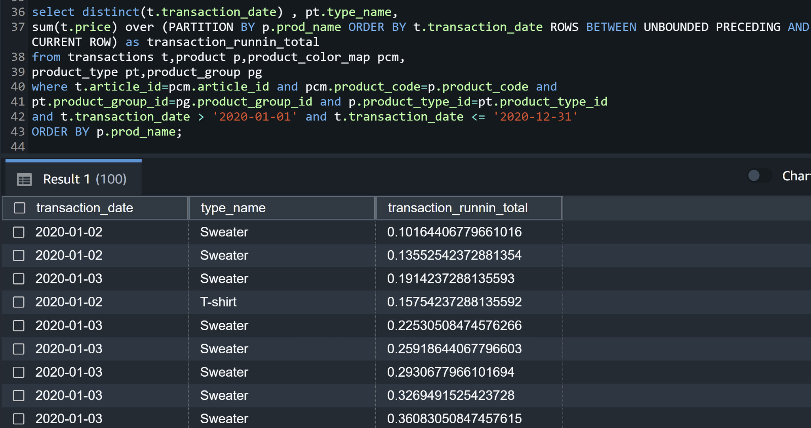

**14. List all the quarters of the years with minimum sales**

select extract(YEAR from transaction_date) as year,

extract(QUARTER from transaction_date) as quarter,

count(price) as number_of_transactions

from transactions

group by extract(YEAR from transaction_date),extract(QUARTER from transaction_date)

order by number_of_transactions, extract(YEAR from transaction_date) asc, extract(QUARTER from transaction_date);

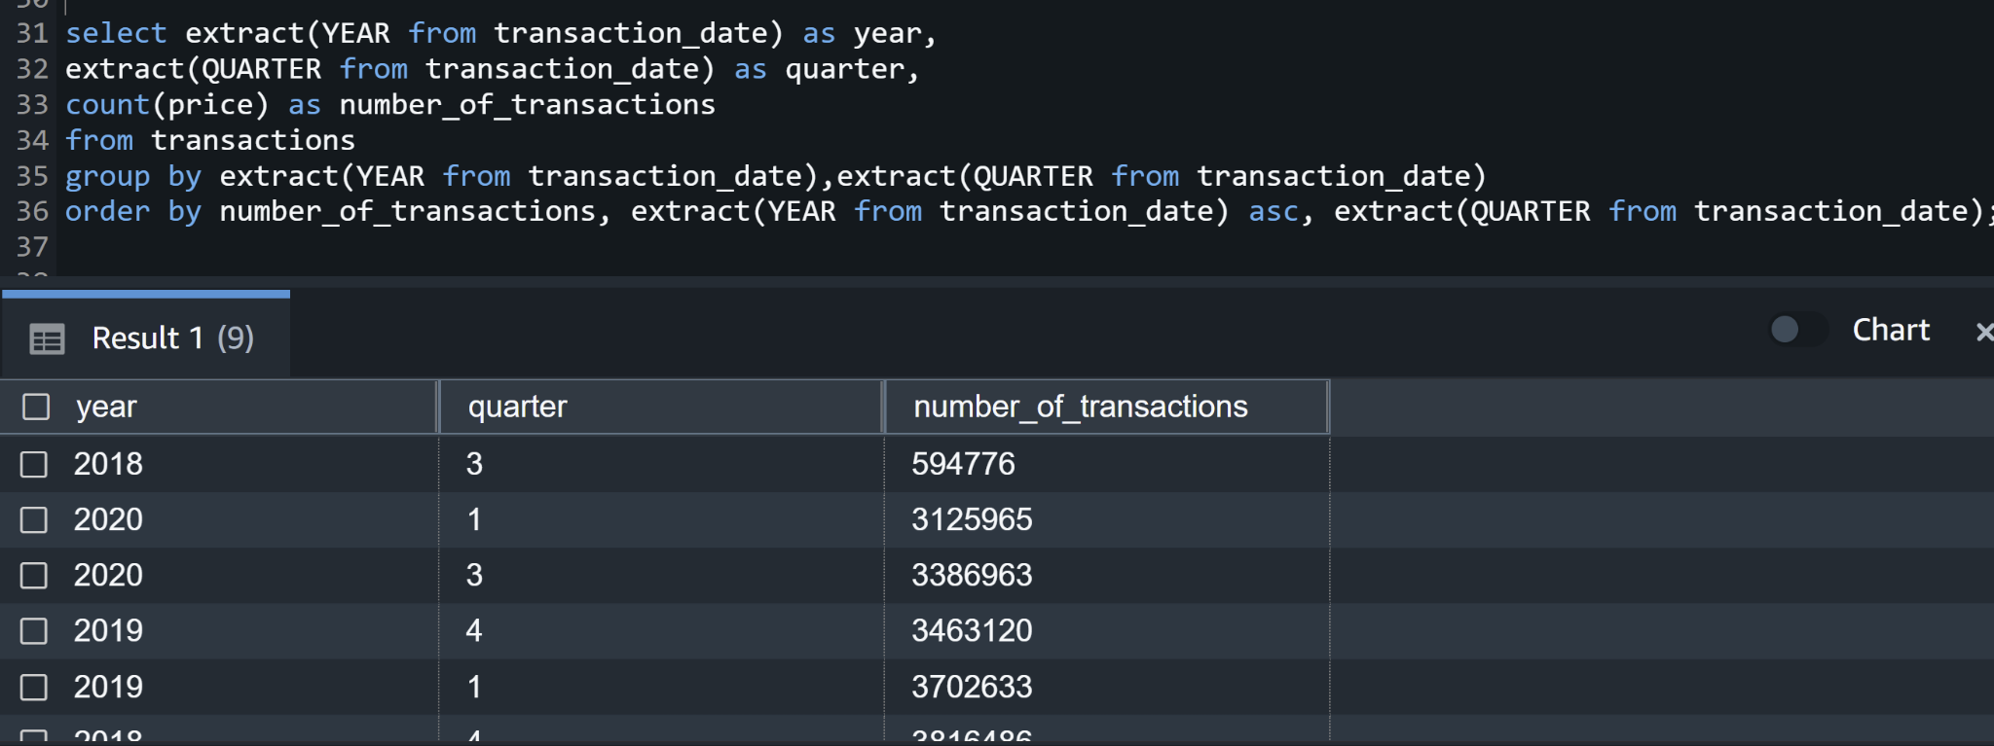

Since 2018, we do not have much data, therefore we can neglect that value.

The second most minimum value of sales happened in the first quarter of 2020.

**15.** **List the first quarter of 2020 with daily sum price and daily price difference**.

select t.transaction_date , sum(t.price) as daily_sum_price,

(sum(t.price) - lag(sum(t.price)) over ( order by t.transaction_date))

as daily_difference

from transactions t,product p,product_color_map pcm,

product_type pt,product_group pg

where t.article_id=pcm.article_id and pcm.product_code=p.product_code and

pt.product_group_id=pg.product_group_id and p.product_type_id=pt.product_type_id

and t.transaction_date > '2020-01-01' and t.transaction_date <= '2020-03-31'

GROUP BY t.transaction_date , EXTRACT(QUARTER from t.transaction_date) asc;

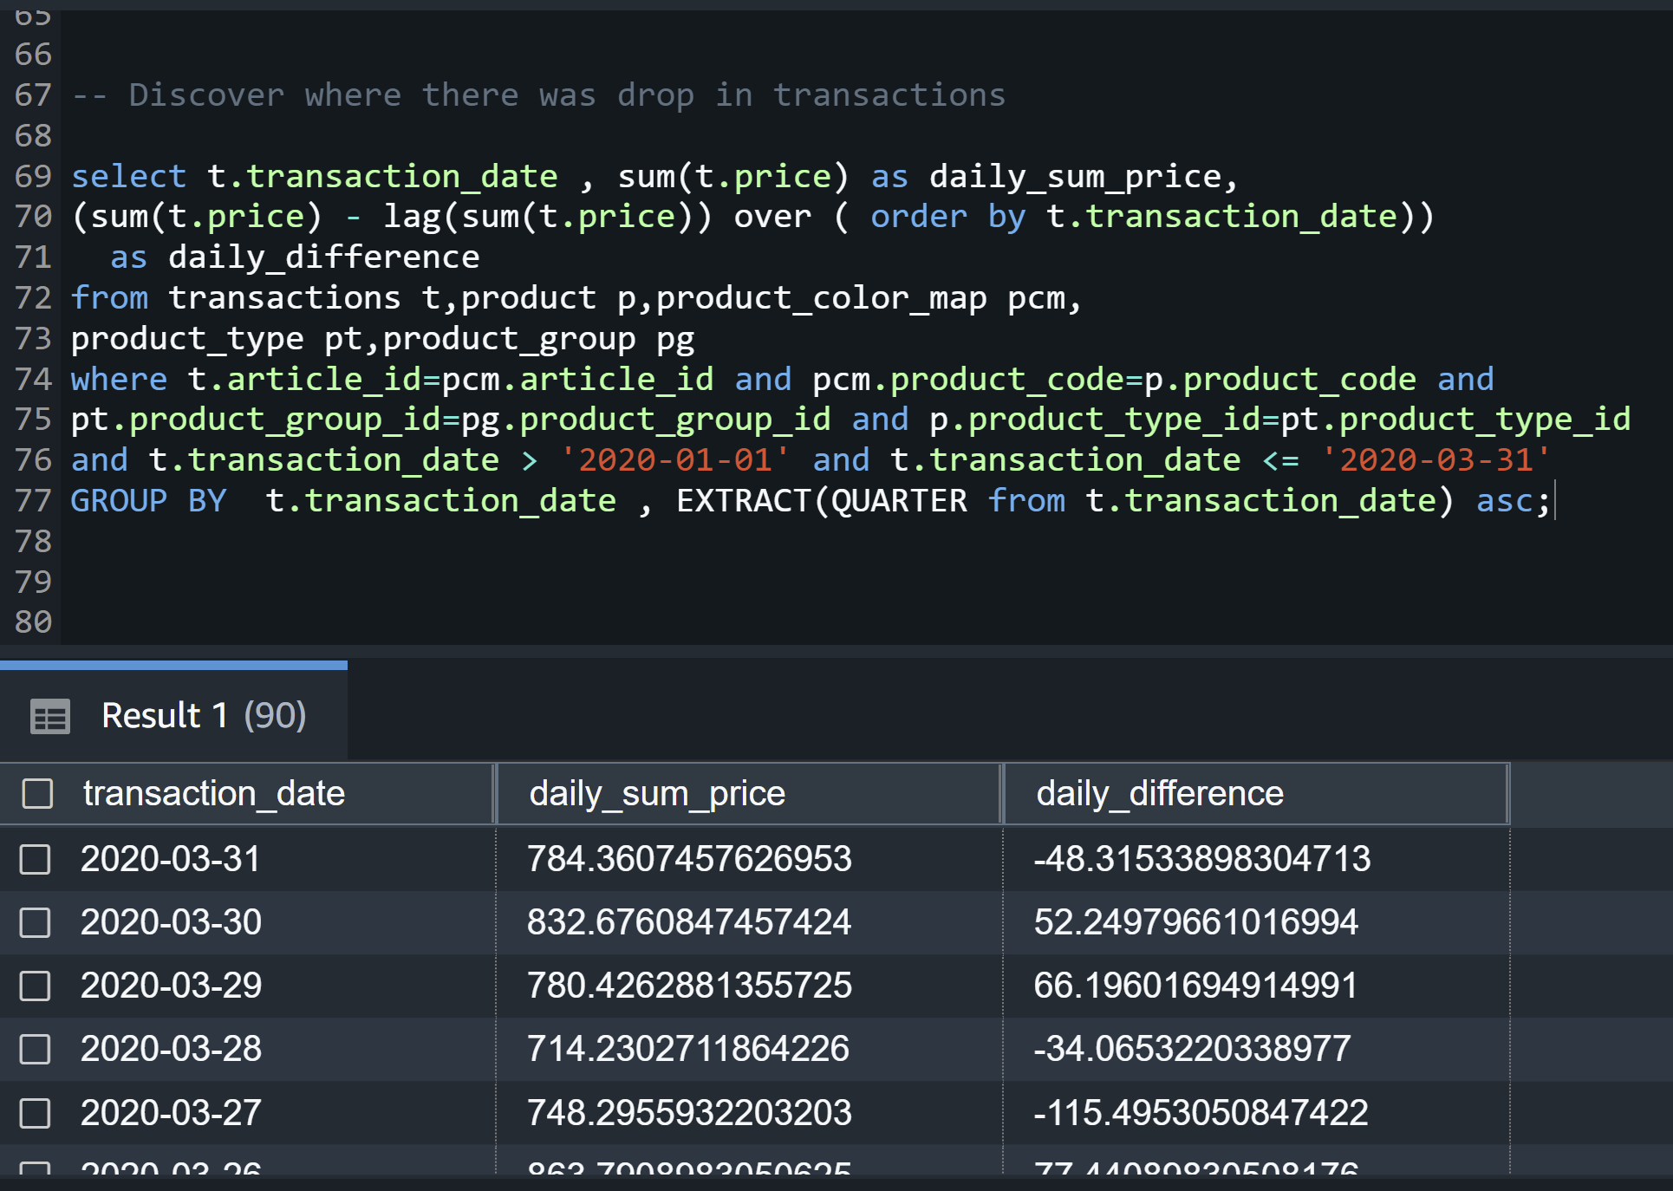

**16.****Customer sales for the year 2019 and 2020. Sales for 2020 has declined for all customers, most probably due to the pandemic.**

select t.customer_id, avg(t.price) as total_sales_per_customer,

SUM(CASE when t.transaction_date >= '2019-01-01' and t.transaction_date < '2020-01-01' THEN t.price else 0 END) as cust_sale_2019,

SUM(CASE when t.transaction_date >= '2020-01-01' and t.transaction_date < '2021-01-01' THEN t.price else 0 END) as cust_sale_2020

from transactions t

Group by t.customer_id order by total_sales_per_customer desc;

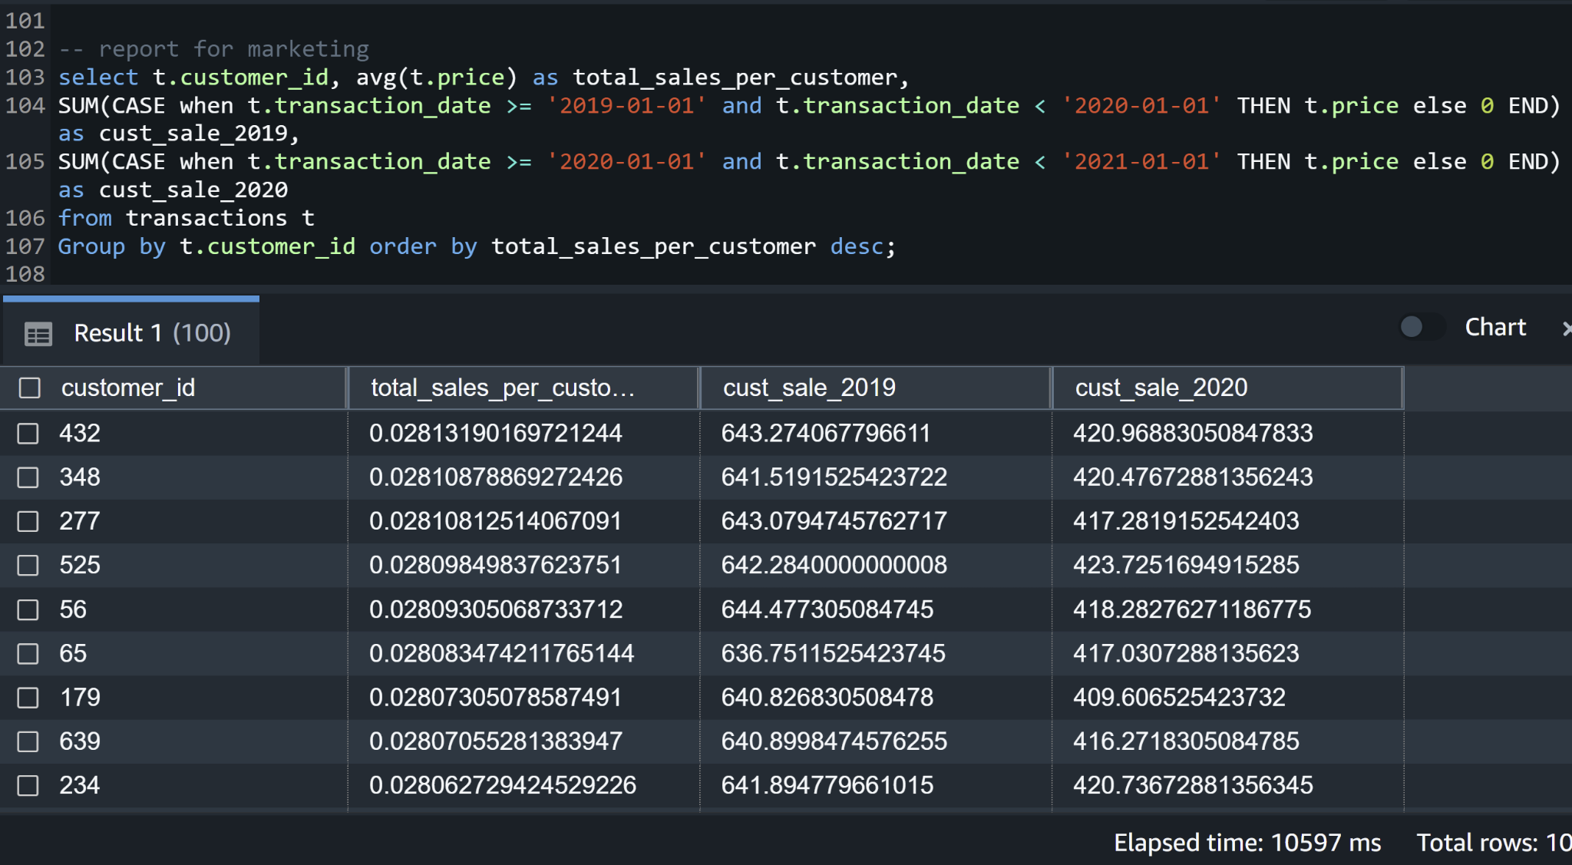

**17.****Cumulative distribution of customer transitions**

select EXTRACT(MONTH from t.transaction_date) as Month, t.customer_id, t.price ,

cume_dist() OVER(

PARTITION BY EXTRACT(MONTH from t.transaction_date)

ORDER BY t.price

) as distribution_price

from transactions t

where t.transaction_date between '2019-01-01' AND '2020-08-31'

order by EXTRACT(MONTH from t.transaction_date) desc;

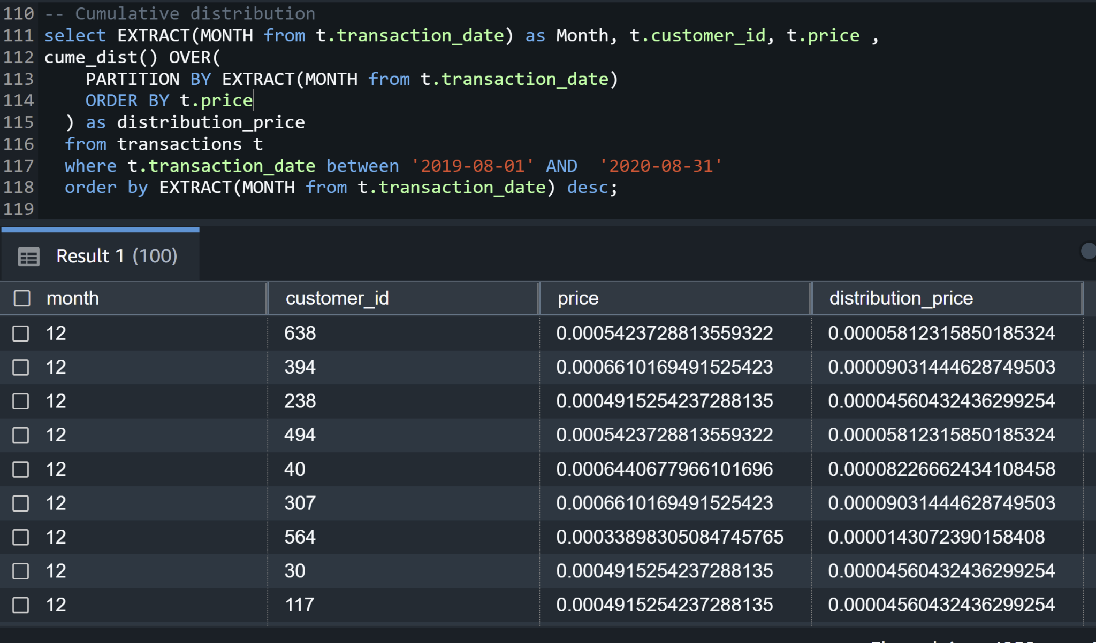

**18.Inventory itemization based on product type, style name, fabric name, color name, count**

SELECT pt.type_name, ps.style_name, f.fabric_name, pc.color_name, T.count

FROM (

SELECT p.product_code, p.product_type_id, pcm.product_color_id, pfm.fabric_id, psm.product_style_id, count(*) as count

FROM product p

JOIN product_color_map pcm on p.product_code = pcm.product_code

JOIN product_fabric_map pfm on p.product_code = pfm.product_code

JOIN product_style_map psm on p.product_code = psm.product_code

GROUP BY p.product_code, p.product_type_id, pcm.product_color_id, pfm.fabric_id, psm.product_style_id

) as T

JOIN product_color pc on T.product_color_id = pc.product_color_id

JOIN product_style ps on T.product_style_id = ps.product_style_id

JOIN product_type pt on T.product_type_id = pt.product_type_id

JOIN fabric f on T.fabric_id = f.fabric_id

ORDER BY pt.type_name, ps.style_name

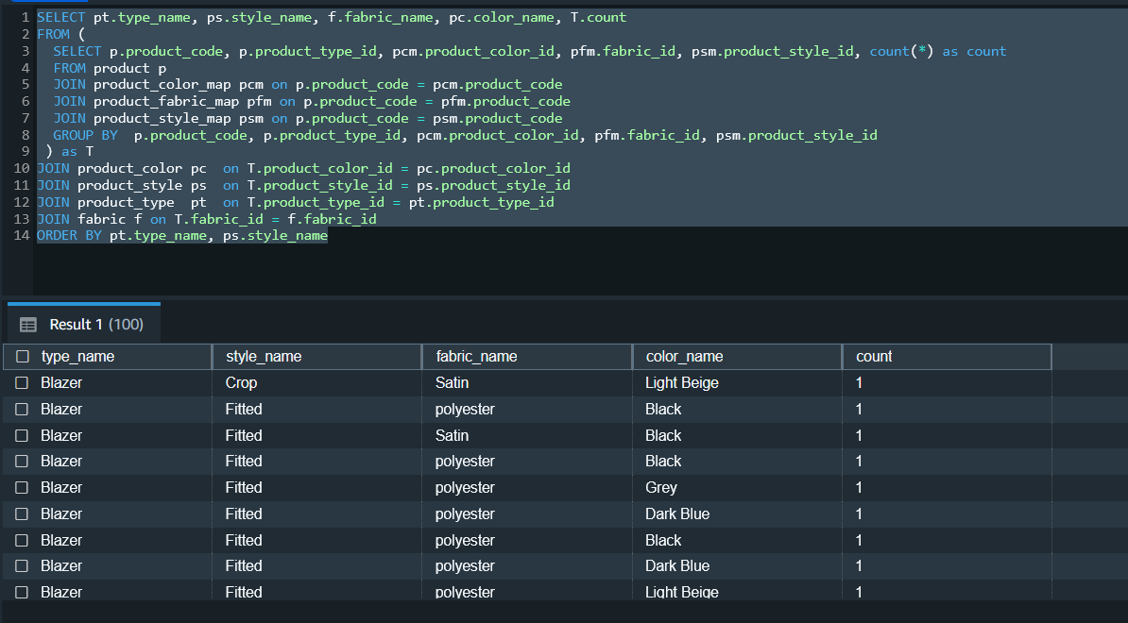

**19. Top 20 Items in inventory based on Product Type, Product Style, Fabric Name and Color**

SELECT U.* FROM

(

SELECT pt.type_name, ps.style_name, f.fabric_name, pc.color_name, T.count

FROM (

SELECT p.product_code, p.product_type_id, pcm.product_color_id, pfm.fabric_id, psm.product_style_id, count(*) as count

FROM product p

JOIN product_color_map pcm on p.product_code = pcm.product_code

JOIN product_fabric_map pfm on p.product_code = pfm.product_code

JOIN product_style_map psm on p.product_code = psm.product_code

GROUP BY p.product_code, p.product_type_id, pcm.product_color_id, pfm.fabric_id, psm.product_style_id

) as T

JOIN product_color pc on T.product_color_id = pc.product_color_id

JOIN product_style ps on T.product_style_id = ps.product_style_id

JOIN product_type pt on T.product_type_id = pt.product_type_id

JOIN fabric f on T.fabric_id = f.fabric_id

ORDER BY T.count DESC LIMIT 20

) as U

ORDER BY U.type_name, U.style_name;

